ABOUT PRODUCT

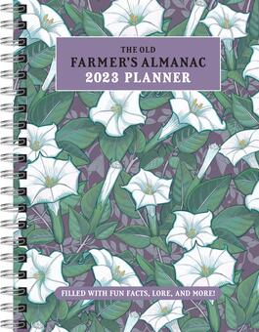
- PREMIUM PAPER: Made with high-quality, 100 gsm acid-free paper in light ivory color, our journal paper is thicker than average notebooks & writing pads, so you can confidently use most pens, pencils, and markers without ghosting and bleed-through.

- LAY FLAT DESIGN FOR WRITING EASE: Our thread-bound notebook is designed to lay flat, making it easier to write for both right and left-handed users. Journaling, note taking and planning has never been more convenient.

PRICE= RS 450

